System Requirement

Specification of

Wind Power Stabilizer.

**Table of Contents**

**1. Introduction**

1. Purpose
2. Document Convention
3. Intended Audience
4. Project Scope
5. References

**2.Description**

1. Product Perspective
2. Problem Features
3. Problem solution and Product Features
4. Operating Environment
5. Design and Implementation Constraints
6. User Documentations
7. Assumptions and Dependencies

**3.System Features**

1. Functional Requirements

**4.External Interfaces Requirements**

1. User Interfaces

**1. Introduction**

**1.1 Purpose**

The purpose of this document is to build a real time system to display power output, weather conditions and forecast time stamps for optimum power production to avoid any kind of overload on power grids.

**1.2 Document Conventions**

This document uses the following conventions:

* Flow chart
* Pictorial Representation

**1.3 Intended Audience**

This project is a prototype for the wind power stabilization system for Wind mill farms. This project has been implemented to stabilize the voltage fluctuations caused due to sudden rise and sudden stop of the wind speed.

**1.4 Project Scope**

The purpose of the Wind Power Stabilizer is to keep an eye on the weather conditions and wind speed. In the initial scenario, wind turbines are equipped with wind speed measuring device known as Anemometer. The device measures wind speed and send the data to the system. If wind speed exceeds the critical speed for the wind turbine, the production is stopped. The real time system may disfunction and the high wind speed may cause damage to the property, wind turbine and livelihood. This system uses weather forecasting to predict possible power output, time stamps when electricity production is possible, time stamps when wind speed will be critical and an Alert email module to send alert messages when wind speed exceeds the critical speed.

**1.5 References**

* <https://pyowm.readthedocs.io>
* [www.energy.gov/eere/wind/how-do-wind-turbines-work](http://www.energy.gov/eere/wind/how-do-wind-turbines-work)

**2. Overall Description**

**2.1 Product Perspective**

2.1.1 Initial Working Conditions

Wind turbines are operated by the help of wind speed. Wind has kinetic energy which depends on its speed. Wind pushes the blades of wind turbines and rotates them. A shaft is connected to the blades which turns the axle of the generator and hence electricity is produced. But there is a minimum need of wind speed is required to turn the blades. This minimum speed of the wind is known as “Cut-in speed”. Generally, the cut-in speed of a fully functional wind turbine lies between 18km/h to 20km/h. After this the production starts and the amount of electricity produced keeps rising until wind speed hits 45km/h. The wind turbines run at their maximum capacity from 50km/h to 80km/h. This range is termed as the “Rated speed”. 80km/h to 90km/h wind speed is considered as the threshold limit of destruction and is termed as the “Cut-out speed”. Electricity production must be stopped after this range. Wind speed more than cut-out speed is so dangerous that the blades may explode and the entire structure may collapse. Sudden increase in voltage may cause damage to the power grids too.

2.1.2 Problem Statement

After the analysis of initial working conditions of Wind turbines, we found that, Wind turbines are equipped with a wind speed measuring device termed as Anemometer. It reads the wind speed and send it to the system. As soon as the speed hits 90km/h the production is stopped by locking the turbine’s blades. But at such a high speed, locking the blades are in vain as possible damage to the turbines may have been done. The blades rotate at a very high speed and cannot be stopped in time.

**2.2 Product features**

The proposed solution is a system that uses forecasting technology to detect the time stamps of “cut-out” wind speed and preparing the blade-locking system to activate before “cut-out” speed manually.

This system gathers weather forecasts available by a trusted third-party API, Openweathermap API. After this it displays the best time duration for optimized utilization of wind turbines, in other words it displays the time stamps when wind speed will be suitable for power production. Then it calculates possible energy output produced accordingly.

It also displays the current weather conditions to monitor. If the wind speed touches cut-out speed, and Alert message is sent using an Email module in the system.

The entire process can be better understood using a work-chart.

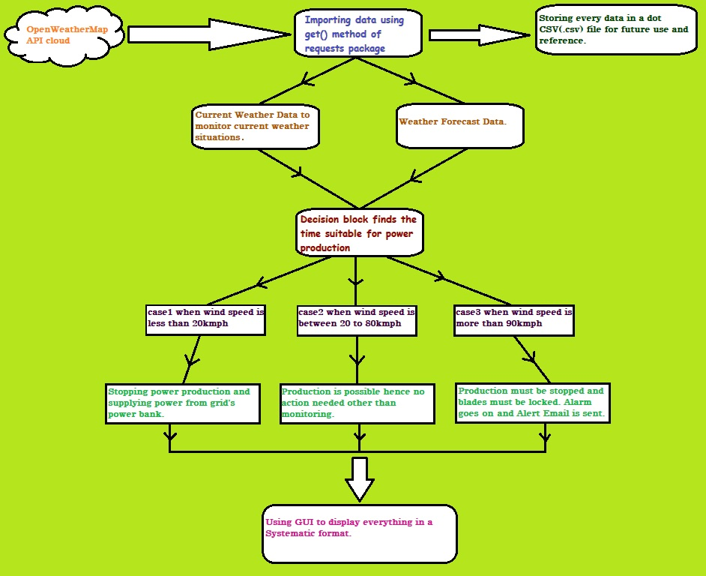

**2.3 User classes and characteristics**

* current_situation_d (): This method will decide whether the wind speed is suitable for energy production or not also it contains the Alert Email module. This method calculates the amount of energy produced at the current wind speed and time.
* Prediction (): This method will predict and decide whether the time stamps imported from the API response is suitable for optimum energy production or not. Also, it calculates the possible energy output at the specific time stamps.
* current_weather (): This method takes city, country or location co-ordinates and provides current weather data such as temperature, wind speed, description and pressure.
* hourly_forecasting (): This method takes city, country or location co-ordinates and provides weather forecasting data hourly.
* three_hourly_forecsating (): This method takes city, country or location co-ordinates and provides weather forecasting data three hourly.
* decision (): This method integrates all the above method and runs the program. This method is also used for error handling.
* reset (): This method is used to reset all the text boxes.
* add (): This method is used to store authority emails.
* one (): Enables city, country input fields and disable lat, long.
* Two (): Enables lat, long input fields and disable city, country.
* clear_log (): Clears log details.

**2.4 Operating Environment**

Operating environment of the Wind Power Stabilizer is as listed below.

* Python V3.8 or above.
* Python package for Open weather map API.
* Internet connection up to 5mbps.
* PyCharm- It is an IDE for python programs.
* Operating System- Windows 7 or above.

**2.5 Design and Implementation Constraints**

1. Internet connection must be stable.
2. Email ID of the concerned authority must be correct.
3. City, Country and lat, long must be correct.

**2.6 User Documentations**

* README.md
* Weather.png

**2.7 Assumptions and Dependencies**

* Assume the gas constant of air is 287.058.
* Assume the radius / length of blades of the turbine is 58 metre.
* Assume the efficiency of the turbine is 40%.

**3. System Features**

**3.1 Functional Requirements**

* Python 3.8 or above.
* Internet connection.
* Pip3 must be installed on the system.
* Latest version of geojson package must be installed.
* Latest version of dnspython package must be installed.

**4. External Interface Requirements**

**4.1User Interfaces**

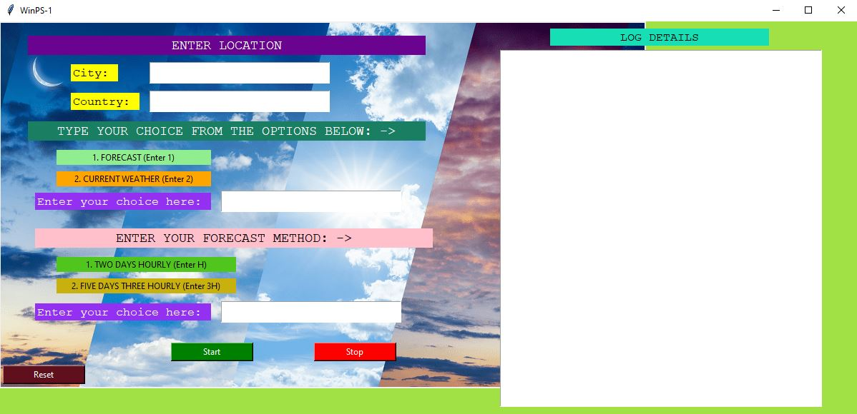Possible look of the GUI.